241/1
History and Political Education
Paper 1
2024
July/August
2 ¼ hours

BSR JOINT PRE-MOCK EXAMINATIONS

2024

UGANDA CERTIFICATE OF EDUCATION

HISTORY AND POLITICAL EDUCATION

PAPER 1

2 HOURS 15 MINUTES

INSTRUCTIONS TO CANDIDATES

- This paper consists of sections A and B. it has four examination items.
- Section A is compulsory.
- Answer one item from section B
- Answer three examination items in all.
- Any additional item answered will not be scored.
- All responses must be written in the answer booklet(s) provided.

Turn over
SECTION A
Answer all items in this section.

- A teacher of history and political education organised study tours for his learners to go and visit various places such as Nyero rock paintings, Amabeere ga Nyinamwiru, Wamala tombs, among others. The teacher wanted the learners to learn more about the history of Uganda through these study tours. On reaching the sites, learners got disappointed when they saw that some of the land that belonged to the sites had been encroached on by the local people. Local people had constructed houses on these sites, opened up large farms, grazed cattle from there as well as cutting down trees from the sites for charcoal burning. The learners suggested that the police should come in and protect such places from the encroachers.

Support material

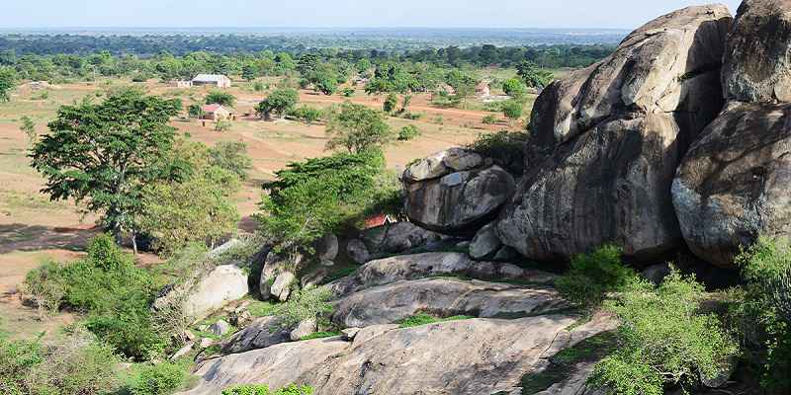

Nyero rock paintings, 29th April 2020, Petnah tours

Tasks:
- Explain reasons why such places should be protected (06 scores)
- What advice would you give to the government of Uganda regarding the best ways of preserving such places (06 scores)

- African countries are becoming the new battle ground for the super powers of the world. Traditional powers like Britain and France have increased their influence on the continent, USA has established military camps in various countries, China has come up strongly to dominate Africa whereas Russia has started displacing Americans from various countries such as Niger. This goes on when many Africans are kept in the darkness.
Your community has faced a similar challenge of the increased number of Chinese, Indians and the Europeans. Although the youths seem to be ok with it, elders are too much worried and concerned of this new development in their community. They believe colonisation has started again. As a way of sensitizing the youths, they have organised a community meeting to tell the youths basing on their past experience during colonial period why they should be worried

Support material

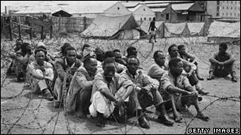
BBC: MAU MAU uprising: Bloody history of Kenya conflict

Task:
Explain the kind of message elders are going to tell the youth

SECTION B
Answer one item from this Section

- While calming down a group of demonstrators in one town, the police used a lot of force characterised by flogging, teargassing, arresting, kicking, and even killing some of these peaceful demonstrators. The local radio station hosted a politician to talk about the saga and he used this opportunity to call upon the local people to come up strongly and defend their constitutional rights against policemen who were abusing them. He went on to say that the constitution is not for the government but rather for local people as citizens of the country. He said it is this constitution that protects their fundamental rights and liberties such as freedom of speech. One caller asked him why he called it a people’s constitution yet it can’t even protect people’s right of peaceful demonstration to express their opinions. Another caller suggested that the constitution should be abolished because it does not benefit people but rather a few officials in the government

Tasks:
- With clear reasons, disagree with the last caller (05 scores)
- Advise the government on how it can involve people in making a good constitution (05 scores)
- When the East African Community was being revived in 2000, East African people received it with mixed feelings. Some people welcomed the idea whereas others opposed its revival. Those that opposed the revival of this organisation claimed that it was to weaken some cultural institutions and waste a lot of money yet at the end of the day, it would fail as the first one did in 1977. The government officials who were in charge of helping this organisation grow got a lot of discouraging messages but they kept focused. Twenty-four years (24) after, the organisation is still in existence but still some people show lack of interest in it.
Your community is one of those communities that up to now don’t show interest in the affairs of the organisation. They feel it’s just a wastage of tax payers’ money and they believe its one of those projects that will fail definitely.

Support material

Overview of Opportunities Under EAC Common Market by Hanningtone Amol & Beatrice Maina 12th 2918
Task:
- With very clear reasons, defend the above organisation (06 scores)

